**Bank ATM**

***UML Use Case Diagram Examples***

An automated teller machine (**ATM**) or the automatic banking machine (**ABM**) is a banking subsystem ([**subject**](http://www.uml-diagrams.org/use-case-subject.html)) that provides bank **customers** with access to financial transactions in a public space without the need for a cashier, clerk or bank teller.

**Customer** ([**actor**](http://www.uml-diagrams.org/use-case-actor.html)) uses bank ATM to **check balances** of his/her bank accounts, **deposit funds**, **withdraw cash** and/or **transfer funds** ([**use cases**](http://www.uml-diagrams.org/use-case.html)). **ATM Technician** provides **maintenance** and **repairs**. All these use cases also involve **Bank** actor whether it is related to customer transactions or to the ATM servicing.

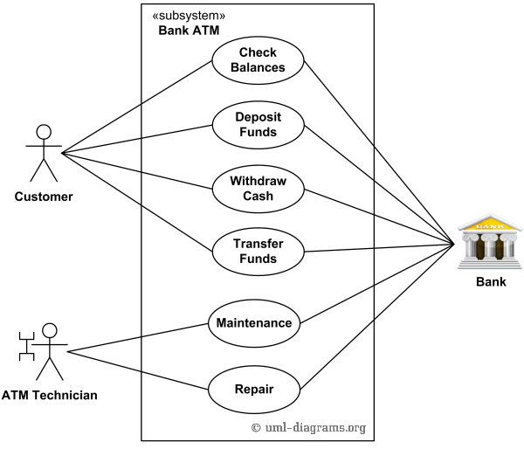

*An example of use case diagram for Bank ATM subsystem - top level use cases.*

On most bank ATMs, the customer is authenticated by inserting a plastic ATM card and entering a personal identification number (PIN). **Customer Authentication** use case is **required** for every ATM transaction so we show it as [**include**](http://www.uml-diagrams.org/use-case-include.html) relationship. Including this use case as well as transaction[**generalizations**](http://www.uml-diagrams.org/use-case.html#generalization) make the **ATM Transaction** an [**abstract use case**](http://www.uml-diagrams.org/use-case.html#abstract-use-case).

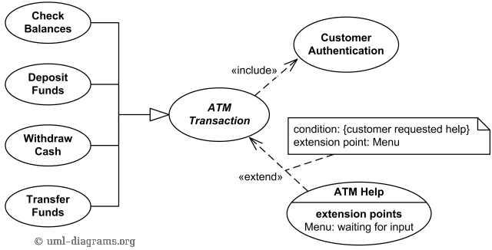

*Bank ATM Transactions and Customer Authentication Use Cases Example.*

If needed, customer may ask ATM for **help**. **ATM Transaction** use case is [**extended**](http://www.uml-diagrams.org/use-case-extend.html) via **Menu** [**extension point**](http://www.uml-diagrams.org/use-case-extend.html#extension-point) by the **ATM Help** use case whenever **ATM Transaction** is at the location specified by the **Menu** and the bank customer requests help, e.g. by selecting Help menu item.

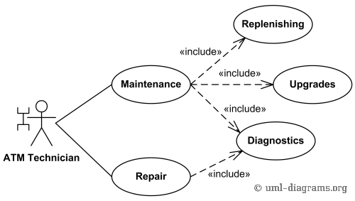

*Bank ATM Maintenance, Repair, Diagnostics Use Cases Example.*

**ATM Technician** maintains or repairs Bank ATM. **Maintenance** use case includes **Replenishing** ATM with cash, ink or printer paper, **Upgrades** of hardware, firmware or software, and remote or on-site **Diagnostics**. **Diagnostics** is also [**included**](http://www.uml-diagrams.org/use-case-include.html) in (shared with) **Repair** use case.